Project Approach – QuizMaster

1. Understanding the Requirements
Before starting development, I carefully analyzed the problem statement to understand the key expectations:
- Build an interactive quiz application
- Ensure responsive design for mobile and desktop
- Provide live feedback after each answer
- Track progress and score
- Maintain accessibility and usability
- Keep Header and Footer consistent across pages
- Use modern frontend practices
This helped me plan the application structure before writing code.

2. Technology Stack Selection
I chose the following tools based on scalability, performance, and industry relevance:
- React.js – For component-based UI development
- React Router DOM – For multi-page navigation without page reloads
- Tailwind CSS – For rapid, responsive, and consistent styling
- Lucide React Icons – For clean and modern UI icons
- Google Fonts – For professional typography
- Public API (Advice Slip API) – To demonstrate API integration

3. Application Architecture
To keep the project clean and maintainable, I followed a modular structure:
- Components – Reusable UI elements (Header, Footer, QuizContainer, Buttons, etc.)
- Pages – Route-level components (Home, Leaderboard, About)
- Hooks – Custom hooks for logic separation (useQuiz, useQuoteFetcher)
- Data – Centralized quiz data using a local JSON file
This separation ensures scalability and readability.

4. Routing Strategy
I implemented client-side routing using react-router-dom:
- / → Home (Quiz)
- /leaderboard → Leaderboard page
- /about → About page.

5. Quiz Logic Implementation
The quiz functionality was handled using a custom hook (useQuiz):
- Tracks current question index
- Stores selected answers
- Calculates score and streak
- Controls quiz completion state
- Supports keyboard navigation for accessibility
This logic is completely decoupled from the UI, improving reusability and testability.

6. Live Feedback & Progress Tracking
After each answer submission:
- Immediate visual feedback is shown (correct / incorrect)
- Correct answer and explanation are displayed
- Progress bar updates dynamically
- Question count (X of Y) is shown at the top
- For continuous Correct Answers, the Streaks are Counted and Displayed.
This improves user engagement and learning effectiveness.

7. Accessibility & Responsiveness
Accessibility was considered throughout the project:
- Keyboard navigation support
- Proper focus handling
- Semantic HTML structure
- ARIA-friendly components where required
Responsive design was achieved using Tailwind’s utility classes, ensuring usability on both mobile and desktop devices.

8. API Integration
In the About page, I integrated an external API to demonstrate real-world usage:
- Implemented loading and error states
- Prevented duplicate API calls caused by React Strict Mode
- Displayed dynamic content with user interaction

9. Styling & Brand Consistency
- Followed the provided brand color palette
- Maintained consistent spacing, typography, and UI patterns
- Used custom utility classes for Google Fonts
- Ensured a clean and modern UI aligned with frontend best practices

10. Testing & Refinement
Before submission, I tested:
- Navigation between pages
- Quiz flow from start to summary
- API behavior on refresh
- Responsive layouts
- Keyboard accessibility
Issues found during testing were iteratively fixed to improve stability and UX.

11. Screenshots

Home Page

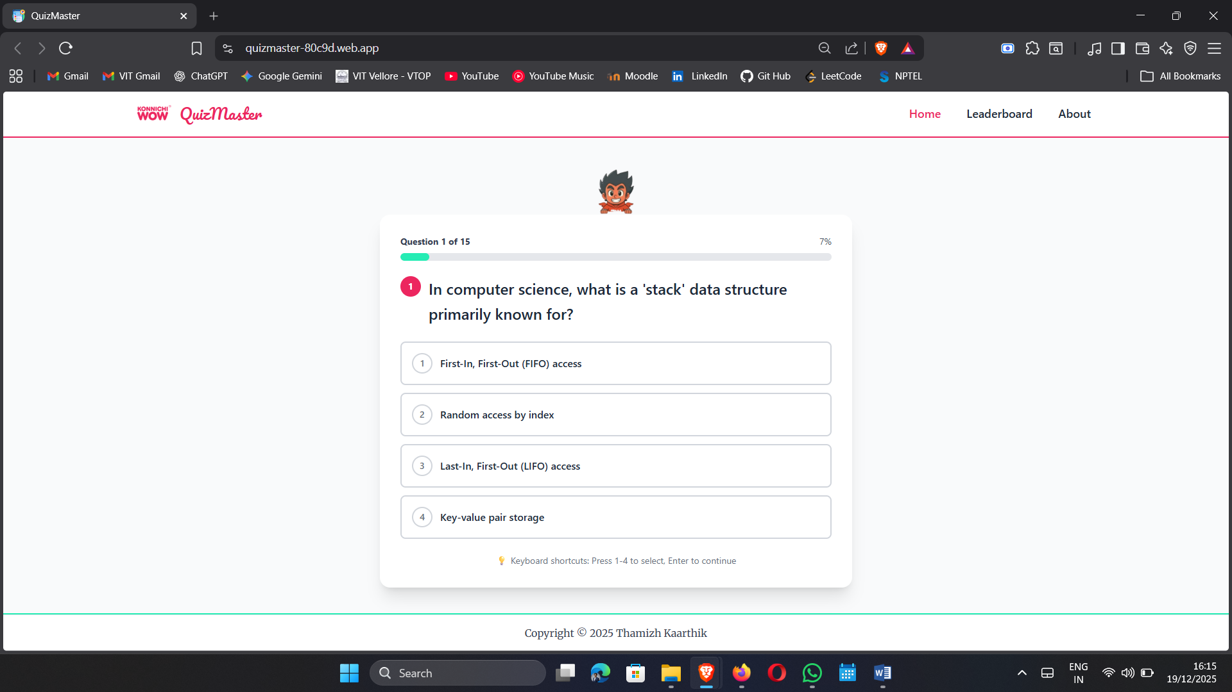

Attempting the quiz!
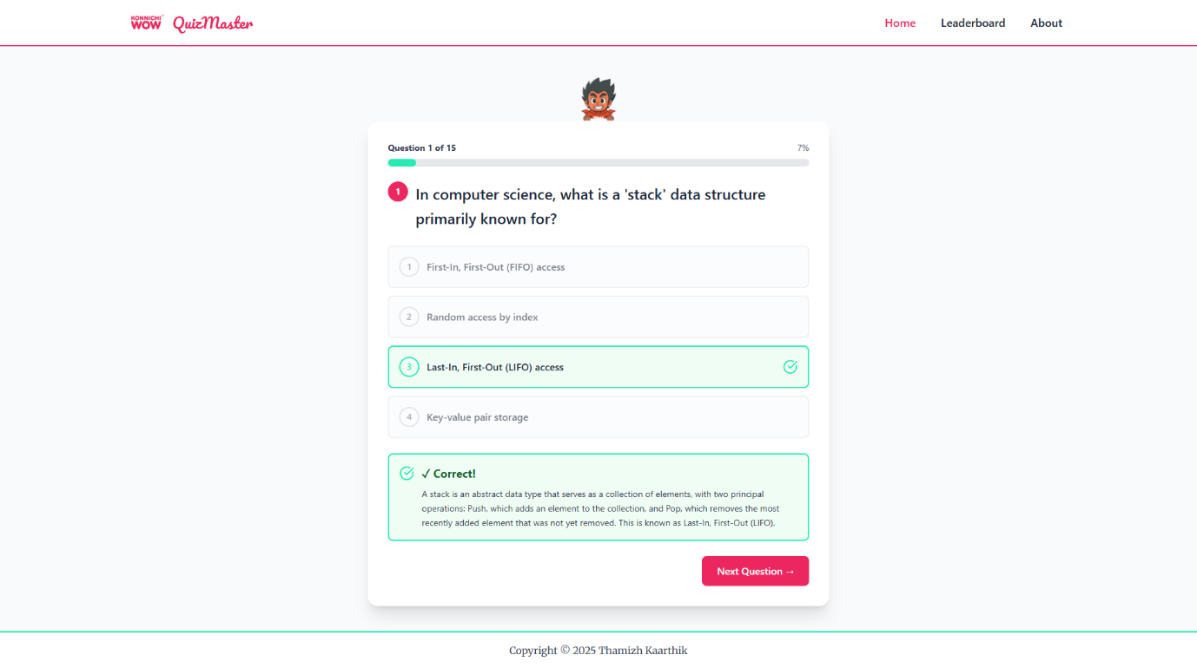

Streak Counted for Continuous Correct Answers!
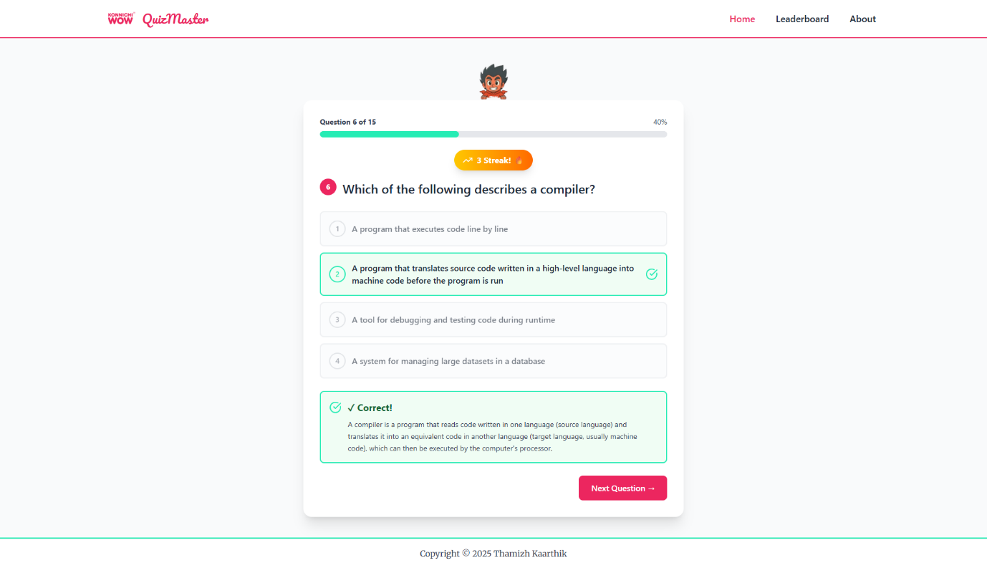

Summary Page!

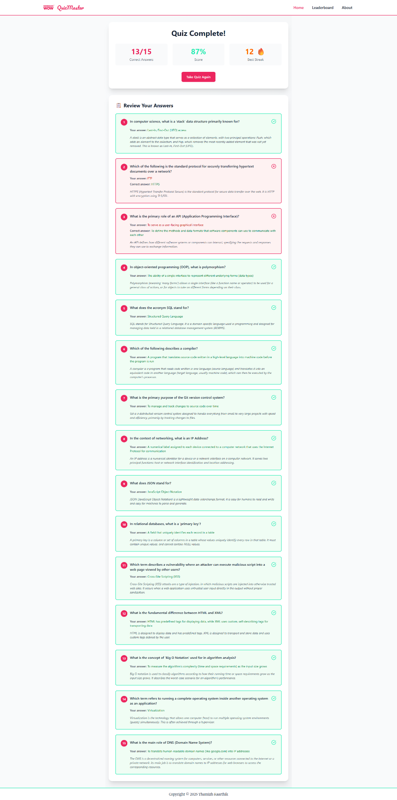
Leadership Page!
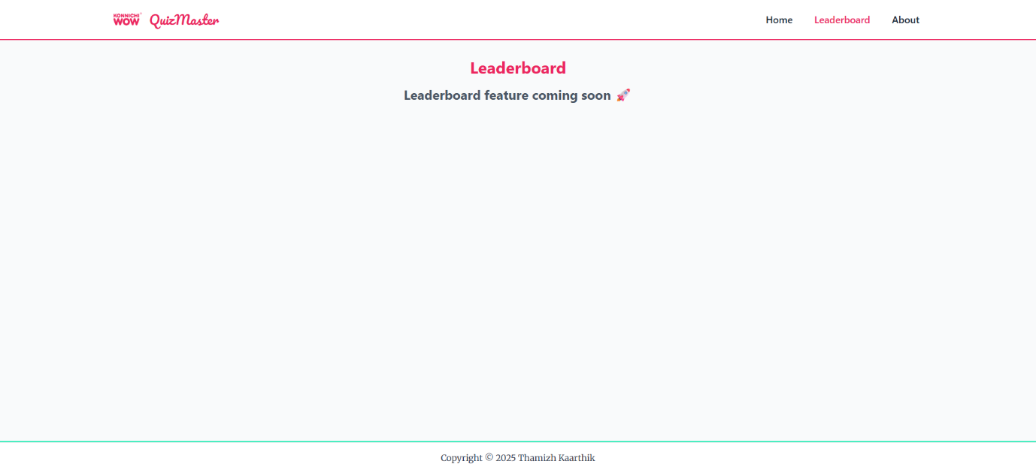

About Page!
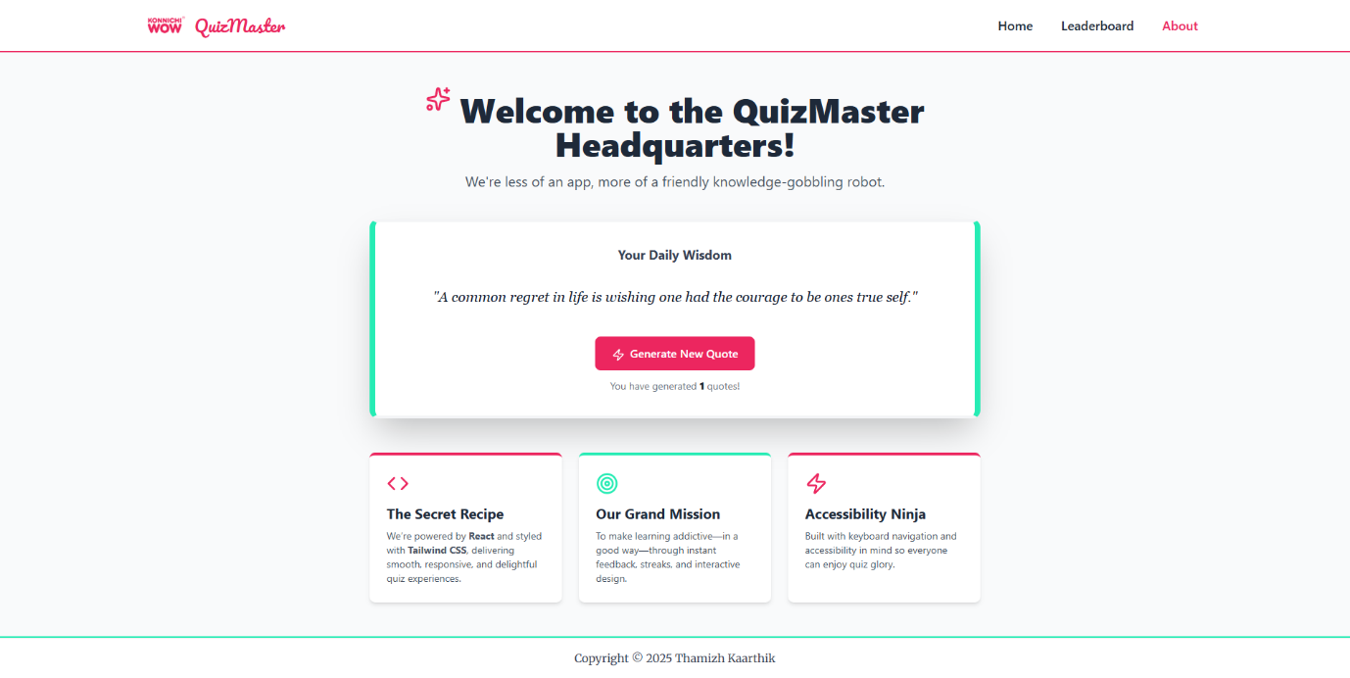

Quotes API Integration!
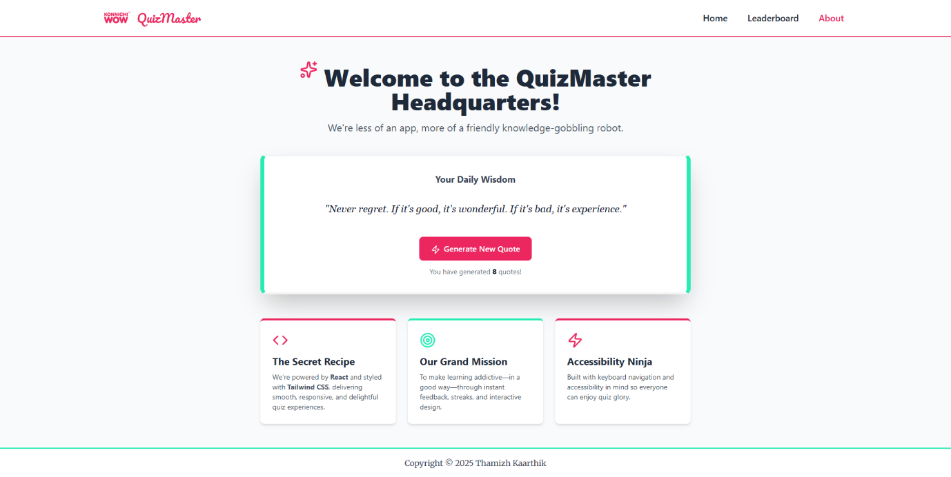

13. Mobile Responsiveness
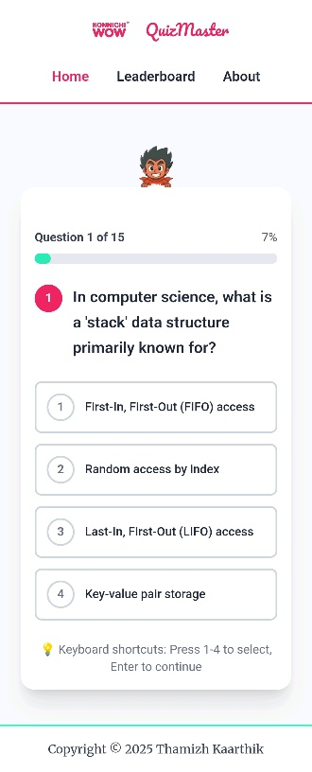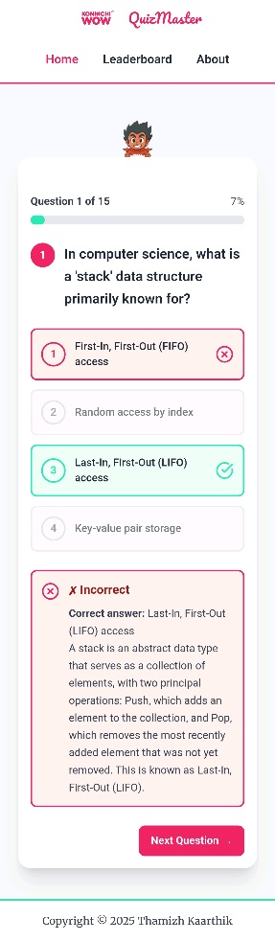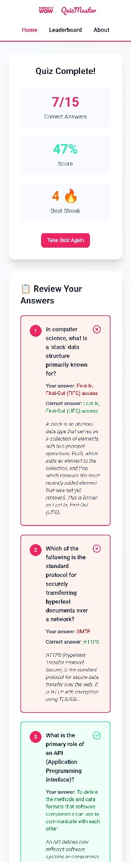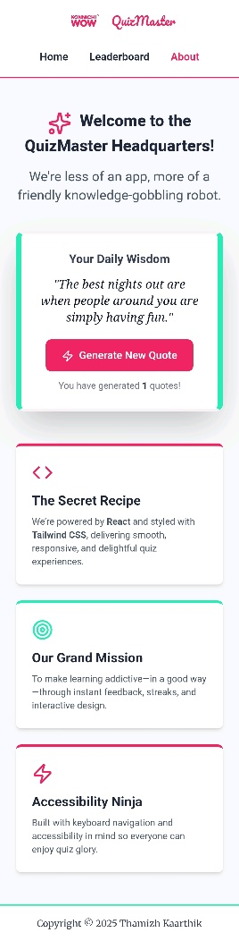

12. GitHub Repository

